INCOSE
Impact of Human Factors Engineering, Systems Engineering, and Information/Communications Technology in Healthcare

Copyright © 2020 by George D. Grant, CSEP Permission granted to INCOSE to publish and use.

Abstract
- Introduction

National Academy of Engineers and Institute of Medicine (NAE/IOM)
- Human Factors Engineering (HFE), Systems Engineering (SE), and Information/Communications Technology (now referred to as IT)

Summary and Conclusions

- United States (U.S.) healthcare delivery system lacks efficiency, quality, coordination, safety, and is costly. Focus has been towards innovation of life and physical sciences, engineering of medical devices, instruments, and equipment treating patients (Reid et al., 2005).

Advancements in healthcare have improved quality of care, but at cost.
- Lack of attention paid to healthcare delivery systems are one of the driving

factors for increased costs (Reid et al., 2005).

- Over past 20 years, engineering has worked collaboratively with healthcare to develop medical devices, equipment, pharmaceuticals, etc. (Reid et al., 2005). However, six reasons were identified why healthcare delivery systems do not adequately support healthcare professionals (e.g., physicians, nurses, administration, etc.), Reid et al. 2005:
  - Industry focused on acute-care (short-term) versus chronic-care (longer-term) treatment.
  - Lack of leveraging advances in technologies and healthcare complexities.
  - Lack of innovation in quality of care and delivery systems.
  - Lack of support and/or focus on IT.
  - Lack of leveraging engineering based-designs and tools utilized in other industries.

National Academy of Engineering and Institute of Medicine…
- In 2001, NAE/IOM Report identified lack of collaboration between healthcare and engineering as primary reason for shortfalls in U.S. healthcare systems (Fowler et al., 2011). Report stated that healthcare systems should be:
  - Safe – Avoids injuries to patients from the care that is supposed to help them.
  - Effective – Provides services to those that could benefit from the enhanced capabilities.
  - Patient-centered – Provides care that is respectful and responsive to individual patient’s preferences, needs, values, and ensuring that patients help to guide all clinical decisions.
  - Timely – Reduces wait-times and harmful delays to patients.
  - Efficient – Avoids waste of equipment, supplies, ideas, and energy.
  - Equitable – Provides a standard level of care to anyone, which does not vary.
- Problems in healthcare have caused between 44,000 to 98,000 deaths and one- million injuries each year (Reid et. al., 2005; Carayon and Wood, 2010).
- So what capabilities are available to help bridge the gap between healthcare and engineering? HFE, SE, and IT.

HFE, SE, and IT…

Human Factors Engineering...

What is HFE?
  - Designing of tools, machines, human-capabilities, and methods to build systems that
are more efficient, comfortable, and safe (Gosbee, 2002).
  - Ensures systems are designed with patient in mind and includes socio-technical elements to identify system boundaries (Carayon, 2006).

In the past, healthcare has focused on improving patient safety by relying on healthcare providers and not always looking at systems holistically (Rivera and Karsh, 2007).

- Three tools identified to understand human factors and systems to improve patient safety (Rivera and Karsh, 2007):
  - Work System Analysis:
    - Healthcare professionals are able to learn and analyze systems or processes. Output is a graphic map of the perceived system or process with inputs, transformation, and outputs.
  - Systems Engineering Initiative for Patient Safety (SEIPS) Model:
    - A conceptual framework for applying SE to patient safety goals. Healthcare professionals play a major
role in the overall process.
  - Human Factors Paradigm for Patient Safety:
    - Derived from SEIPS model, but shows how healthcare systems can influence provider and outcomes, such as patient and provider safety.

SEIPS and Human Factors Paradigm for Patient Safety (Input- Transformation-Output) Models.

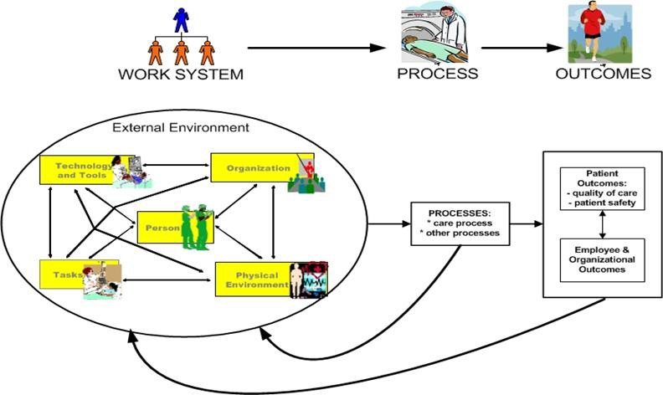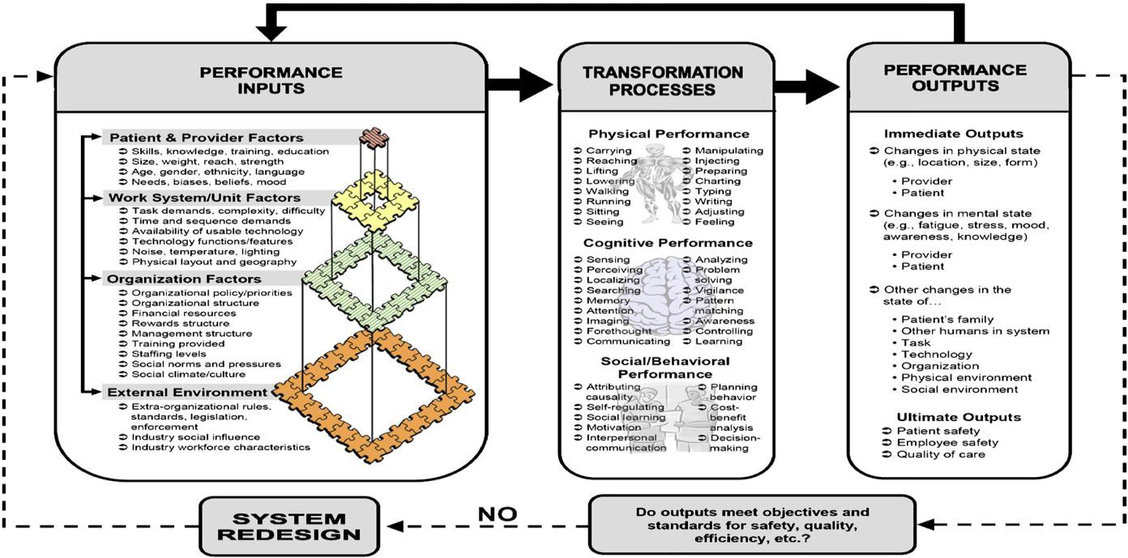
SEIPS Model
Input – Transformation – Output Model

Source: (Rivera and Karsh, 2007; Carayon and Wood, 2010)
Source: (Rivera and Karsh, 2007; Carayon and Wood, 2010)

SEIPS Model 2.0 (Integrated View of SEIPS 1.0 and Input-Process- Output Models on Previous page).
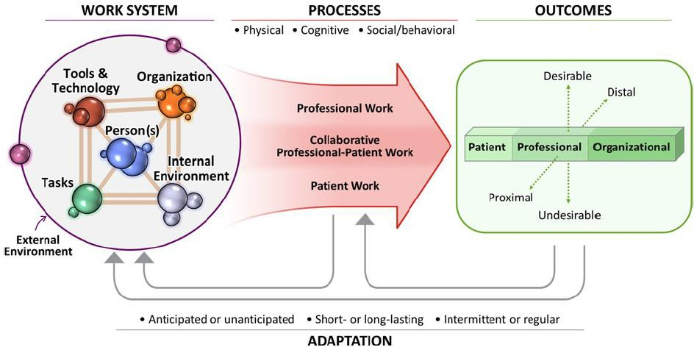
Holden, R.J., Carayon, P., Gurses, A.P., Hoonakker, P., Schoofs Hundt,A., Ozok^{ghi}, A.A., Rivera-Rodriguez, A.J., Ergonomics (2013): SEIPS 2.0: a human factors framework for studying and improving the work of healthcare professionals and patients, Ergonomics, DOI: 10.1080/00140139.2013.838643.

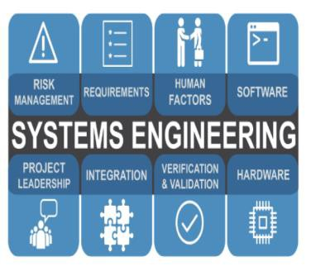Systems Engineering…

- What is SE? A disciplined methodology for building cost-effective, efficient, and scalable systems to support stakeholders requirements. It analyzes how the different system elements (internal and external) interact with System of Interest (SOI) from concept through retirement.
- Benefits of SE? Holistic (SE) viewpoint across multiple disciplines, planning and coordination,
reduced costs, and implementation of effective systems.
  - Benefits of SE were realized during implementation of the Emerge System at Johns Hopkins University (Pronovost, Ravitz, and Grant, 2017). Hospitals and clinics tend to implement complex processes and stove-pipe systems that may lack integration. If systems were more integrated it could improve patient diagnosis through a variety of means (e.g., electronic devices, electronic medical records, etc.), Pronovost et al., 2017.
  - Project Summary:
    - Project involved collaborating with SEs and integrators located at Johns Hopkins University Applied Physics Laboratory (APL). Objective was to improve patient safety and quality of care in Intensive Care Units (ICU), Pronovost et al., 2017.
    - Over twenty different disciplines were involved in defining goals, priorities, requirements, and performance measures.
    - During requirements definition process with stakeholders, clinicians, and patients, a detailed set of requirements were developed to building system capabilities.
    - Requirements focused on integrating data between multiple sources (e.g., electronic patient records and sensors for tracking patient activity) into one integrated computer display. Outcome provided a way to quickly identify and prevent some of the common problems in ICUs, such as hospital-related infections and complications (Pronovost et al., 2017).

- SE Standard:
  - International Standards Organization, International Electrotechnical Commission, and Institute of Electrical and Electronics Engineers (ISO/IEC/IEEE) 15288 standard provides SE life cycle stages to ensure a disciplined process is used as a system progresses from concept through retirement stages (International Council on Systems Engineering (INCOSE) Handbook, 2015).

- Concept – Begins with a new or modified system. It includes defining the problem space, identifying stakeholders, developing a feasibility concept, and providing the final solution.  - Development – Defines and realizes the system of interest (SOI) to meet stakeholder requirements. Requirements are defined, architecture developed, and implement initial system (e.g. prototype).  - Production (IMPL) – Produced or manufactured, verified and validated through testing, and prepare for operations.  - Utilization (OPS) – Operated in intended environment to deliver services.  - Support – Provide sustainment or maintenance services to enable continued operations.  - Retirement – System and related services are removed from the environment. | 1. Concept  - Define problem space.  - Identifying stakeholders.  - Develop concept.  - Determine final solution. | - Define SOI to support stakeholder requirements.  - Development • Develop requirements.  - Develop system design /  architecture.  - Implement initial system.  - Production  - Implement and test system.  - Prepare for operations. |  | - Operated in intended environment.  - Utilization  - Support | - Remove system and related services from environment.  6. Retirement  - Sustainment and/or maintenance.
Advancing the Practice of Systems Engineering in the Healthcare Industry |  |  | 6 November 2020

To improve patient safety, quality outcomes, and reduce costs, Industrial Engineering Departments within U.S. have been working to developed Healthcare Systems Engineering Programs to enhance patient care. Some of the Universities involved, included (Fowler, et al., 2011):
  - Arizona State University,
  - Georgia Institute of Technology,
  - University of Wisconsin-Madison, and
  - Others.

These and other efforts has led to Healthcare Systems Engineering Programs developed at Johns Hopkins University, University of Central Florida, Lehigh University, etc., to help bridge the gap between healthcare and engineering.

HFE, SE, and IT…

Information Technology…

- For decades, healthcare industry has made less use of IT than other industries. In 1990, healthcare industry ranked 38 out of 53 non-farm related industries in the U.S. (Reid et al., 2005). Although IT gap is closing, core healthcare operations are still lacking effective capabilities to improve quality, efficiency, and reduce cost.
- IT used in healthcare:
  - Project Summary 1: Design for Analgesia Device Interface. Analgesia is a medicine used to reduce pain.
    - During an experimental study to show application of HFE, while designing an analgesia device interface, results showed that new interface eliminated a concentration of drug errors and other problems (Carayon and Wood, 2010).
  - Project Summary 2: IT Pilot Project to Improve Patient Care for Multinational Retail Corporation:
    - Identified problem areas and used IT systems and methods to verify and validate its healthcare delivery
system. Pilot project is now operational and has been implemented in Pharmacies nationwide.

HFE, SE, and IT…

Information Technology (Cont.)…

- Before IT systems are implemented, SEs must ensure systems comply with cybersecurity policies or requirements of the hospital/organization. In addition, the following should be considered before acquiring and implementing an IT system (Carayon and Wood, 2010):
  - Top management commitment to change,
  - Responsibility and accountability structure for the change,
  - A structured approach to the change,
  - Training,
  - Pilot testing,
  - Communications.
  - Feedback,
  - Simulations, and
  - End-user participation.

Summary and Conclusion…

- Healthcare delivery system lacks coordination, efficiency, integration, quality, and is costly. The NAE/IOM Report (2001) expressed need for healthcare and engineering to work together to build a better healthcare system (Fowler et al., 2011).
  - Lack of effective healthcare systems can lead to patient harm, low productivity, and excessive cost (Pronovost et al., 2017).
- Use of HFE, SE, and IT play an important role collectively to bring efficiencies, quality of care, reduce cost, minimize errors, and more to improve healthcare.
- SE:
  - Provides the glue that brings all of the different disciplines (HFE, IT, etc.), people, processes, and technologies together to serve the whole. It is a central component of successful systems.
  - Provides breadth and depth to effectively analyze complex problems, define requirements, determine performance measures, design, implement, and test systems.

HFE, SE, and IT…

Summary and Conclusion (Cont.)…

INCOSE has established a Human Factors Working Group to meet growing challenges in healthcare to not only build the system, but ensure the right system is built.
- High-level SE model for building effective systems:
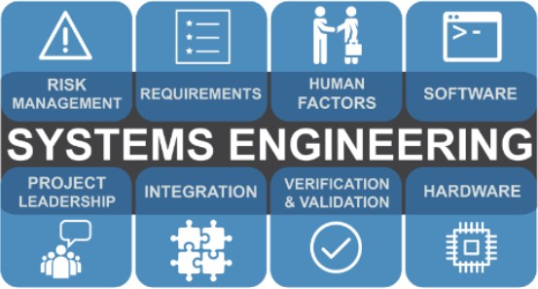
Source: https://www.incose.org/systems-engineering

About the Author

- Title: George Grant works for U.S. Department of Defense as an electronic systems engineer.
- Experience: Over the past 35 years, he has led and supported a wide array of projects in telecommunications, IT, SE, project management, and technical management.
- Affiliations: INCOSE, National Society of Black Engineers (NSBE), American Society for Engineering Management (ASEM), and Project Management Institute (PMI). During his spare time, he works as a volunteer to help students become aware of opportunities in Science, Technology, Engineering, and Math (STEM).
- Education:
  - Degree of Engineer, Systems Engineering from George Washington University; Master of Engineering (M.Eng.) in Engineering Management from Stevens Institute of Technology); M.S. in Systems Engineering from Johns Hopkins University; M.S. in Telecommunications Management from University of Maryland; and
B.S. in Electrical Engineering Technology (Power Option) from Kennesaw State University.
- Certifications:
  - INCOSE Certified Systems Engineering Professional (CSEP); Engineering (ENG) Level 3 Certified with the Defense Acquisition Workforce Improvement Act (DAWIA), Defense Acquisition University (DAU); Security+; and Certified Data Center Design Professional (CDCDP).

Acronym Explanation

ICU Intensive Care Unit
IEC International Electrotechnical Commission IEEE Institute of Electrical and Electronics Engineers INCOSE International Council on Systems Engineering IOM Institute of Medicine
ISO International Standards Organization
IT Information Technology
NAE National Academy of Engineering
NSBE National Society of Black Engineers
PMI Project Management Institute
SE Systems Engineering
SEIPS Systems Engineering Initiative for Patient Safety (SEIPS)

- Carayon, P. (2019, March). “Using a Human Factors and Systems Engineering Framework to Build Safer Patient Care Processes. Agency for Healthcare Research and Quality. https://www.ahrq.gov/funding/grantee-profiles/grtprofile-carayon.html.
- Pronovost, P., Ravitz, A., Grant, C. (2017, February). “How Systems Engineering Can Help Fix Health Care”. Harvard Business Review.
- International Council on Systems Engineering (INCOSE), Systems Engineering Handbook, A Guide for System Lifecycle Processes and Activities. Fourth Edition. (2015). Wiley.
- Holden, R.J., Carayon, P., Gurses, A.P., Hoonakker, P., Schoofs Hundt,A., Ozokghi, A.A., Rivera-Rodriguez, A.J., Ergonomics (2013): SEIPS 2.0: a human factors framework for studying and improving the work of healthcare professionals and patients, Ergonomics, DOI: 10.1080/00140139.2013.838643
- Fowler, J.W., Benneyan, J.C., Carayon, P., Denton, B.T., Keskinocak, P., Runger,
G.C. (2011). “An Introduction to a new journal for Healthcare Systems Engineering”. IIE Transaction on Healthcare Systems Engineering. DOI: 0.1080/19488301003645051

  - Carayon, P., Wood, K.E. (2010). “The Role of Human Factors and Systems Engineering”. Studies in Health Technology Informatics. 153: 23–46.
  - Kopoach-Konrad, R., Lawley, M., Criswell, M., Hasan, I., Chakraborty, S., Pekny, J., Doebbeling. (2007). “Applying SE Principles in Improving HC Delivery”. Society of General Internal Medicine. (Supplement 3): 431-7. DOI: 10.1007/s11606-007-0292-3.
  - Rivera, J.A., Karsh, Ben-Tzion. (2007). “Human Factors and Systems
Engineering Approach to Patient Safety for Radio Therapy”. Int. J. Radiology Oncology Biol. Phys. Vol. 71, No. 1, Supplement, 174-177. DOI: 10.1016/j.ijrobp.2007.06.088.
  - Carayon, P. (2006, July). “Applied Ergonomics Human factors of complex socio- technical systems”. Applied Ergonomics.

  - Gosbee, J. Quality Safe Healthcare. (2002). 11:352-354. http://qualitysafety.bmj.com
  - Reid, P.P., Compton, W.D., Grossman, J.H, et al., Editors. (2005). “Building a Better Delivery System: A New Engineering/Healthcare Partnership National Academies Pres (US).

Systems Engineering. Transforming Needs to Solutions. https://www.incose.org/systems-engineering

Thank you for attending!
Share your experiences at #HWGSEC

